# Assignment 4

## Screenshots

* + A screen shot of the GUI with several properties.

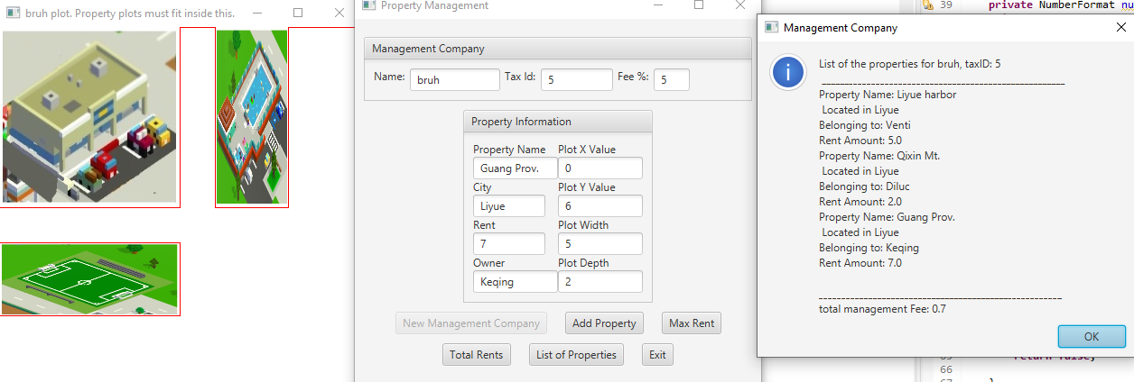

Max Rent

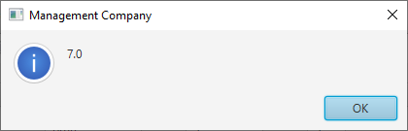

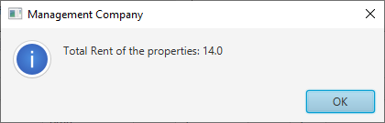

## Learning Experience

I didn’t really learn anything over the course of the project. I guess I got more experience implementing code that someone else has specified. I can definitely see how planning out your code before hand can make the entire process easier. For example, having the java doc prior to hitting the text editor was helpful because I didn’t have to think as much as I would have if I didn’t have all the methods planned out for me.